**Challenge 2**

**Automated Document ingestion system**

**This document will provide a step-by-step guide to configure and run the entire solution. For the ease of navigation, the guide is divided into 6 different key steps.**

**Prerequisites**

1. **Deploying and configuring Forms Recognizer**
2. **Deploying and configuring Storage account**
3. **Training and testing Forms Recognizer**
4. **Creating Automation with Logic app and cosmos DB**
5. **End to End test**

**p.s. In certain steps you will need to use exact names or settings as provided in the guide, these are highlighted in the red in the guide.**

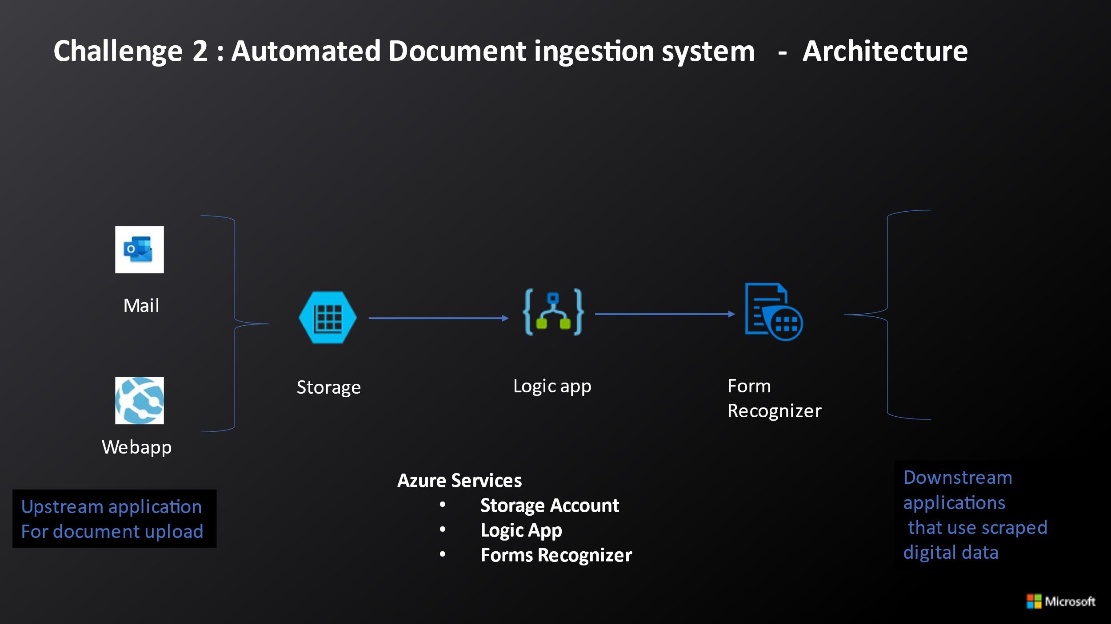

# Step 0 - Before you start (Pre-requisites)

These are the key pre-requisites to deploy this solution:

* You need a Microsoft Azure account to create the services used in this solution. You can create a [free account](https://azure.microsoft.com/en-us/free/), use your MSDN account, or any other subscription where you have permission to create Azure services.
* Go to the github repo for the hack <https://github.com/shkumar64/msbankinghack>

Click on code and download Zip. Create a folder on your PC and unzip the contents

# Step 1 – Provision and Configure Forms Recognizer

# Long onto Azure portal with your credentials – ms.portal.azure.com

# Create a resource group and name it FSIBankinghack (or any name of choice) you can keep using the same resource group as challenge 1.

# Search for Forms Recognizer on the search bar and click on create button

# Choose a name and select standard S0 as pricing tier and choose review plus create.

# Step 2 – Provision and Configure Storage Account

# Forms recognizer needs a storage account to train models, so let’s create one.

# Search for storage account on top search bar

# Choose the same resource group and standard then click on create

# Go to the storage account and create 2 containers named training and ingestion. Choose Private for this use case

# Go to the training container and select upload, navigate to challenge2/Forms in the content downloaded as part of step-0 and upload all 5 forms.

# Forms recognizer labeling tool requires CORS to be enabled on the storage account. On the main storage account page, scroll down to settings and select Resource Sharing(CORS)

# Add settings as below and select save

# Step 3 – Training and testing Forms Recognizer

# On the browser navigate to the FOTT labeling tool

# <https://fott-2-1.azurewebsites.net/>

# Select Use Custom to train model with labels

# Select new project , choose a name and then click on Add connection

# Choose a name. For the Sas URI navigate to the training container on the storage account and select Shared access. Add the permissions below and use start time 1 day before today and end time 1 month after today. Copy the sas URL and paste it on the fott tool and save the connection.

# After the connection is saved click again on new project and this time select the connection we created.

# Navigate to the forms recognizer resource on Azure and copy the Endpoint and paste as Forms Recognizer service URL on the FOTT tool

1. Select keys and paste it to the FOTT tool as well as API key and click on save
2. Now you should be able to see Forms from the training folder
3. Graphical user interface, text, application

   Description automatically generated

On the right Select Tags and create following tags

* + **Name of the professional corporation**
  + **Address**
  + **City**
  + **State**
  + **Zip Code**
  + **Agent Name**
  + **Number of Shares**
  + **Signed Name**

1. In each of the forms select correct value associated for each of this tag and then click on the tag to assign value to the tag. Repeat this for all 5 forms.

1. After tagging click on train icon to train the model

1. After Model is trained we can test it. Click on analyze icon on the right.

1. Select one of the forms from challenge2/Test and look at the output

# Step 4. Creating Automation with Logic app and cosmos DB.

1. We will walk you through the next steps during the lab